COURSE OVERVIEW
The GCSE History course is comprised of the following units:
Edexcel 9-1 Historians study 4 units
- Medicine Through Time
- Anglo-Saxon England and the Norman Invasion
- Germany 1918-1939
- Superpower Relations 1943-1991

EXAMINATIONS
Edexcel 9-1 History has 3 exams between 75 minutes and 105 minutes.
- Exam 1 – Medicine through time – 30%
- Exam 2 – Normans and Cold War – 40%
- Exam 3 – Germany – 30%
All exams will be sat in Summer 2023

REVISION
We aim to finish teaching by February Half Term 2023. This will allow teachers to start revision after the break. We offer revision sessions and evening schools to support revision.
We will also provide students with bespoke revision packs which support students to reach their potential. These resources will be stored on students iPad either using the OneDrive app or the OneNote app.
Finally, we also have a vast number of resources on Firefly which have been produced by the department. These include practice papers, revision guides and exemplar answers. These can be found using the link below:
https://jhs.fireflycloud.net/history/ks4/gcse-9-1-edexcel-history/revision-resources

HOW TO HELP YOUR CHILD IN HISTORY
The biggest help we can receive from parents is testing students on their knowledge.
We have produced a series of knowledge quiz booklets. Please try to test students 3-4 times a week on a variety of topics. They contain the key learning that everyone must know if they wish to achieve a good grade. The knowledge test booklets can be found on Firefly, please use the link below:
https://jhs.fireflycloud.net/history/ks4/gcse-9-1-edexcel-history/revision-resources/knowledge-quiz-question-booklets
These will also be emailed out via ParentMail. Please look out for emails from the History department.

Also encourage your child to access the revision resources on Firefly. These include practice question booklets which will help students with exam technique and resources such as revision cards which you could help to test student’s knowledge at home.

Finally encouraging students to access the following resources will also help to improve their grades.
- GCSE Pod - Students can use GCSE Pod to watch videos 3-5 minutes in length. The department has created question booklets that students answer. It would then benefit students to be tested on this knowledge – so please ask to see their booklets. This can be accessed via their iPads and students should email their teachers if they have forgotten their login details. https://www.gcsepod.com/
- Pixl History App - Students have a login for the Pixl History app which can be accessed via their iPads. This can be accessed on a computer or via the app on a phone or tablet. This contains knowledge quizzes to test students’ knowledge on all topics. https://historyapp.pixl.org.uk/History%20App2.html
- Massolit - This resource contains a series of lectures on Ancient History. This will help students to recap their knowledge and extend their knowledge for the top grades. Students can sign up to the website using their @jhs.pkat.co.uk email address. https://massolit.io/
- Historical Association – This resource contains a series of podcasts, articles and more to help students recap and extend their knowledge. Students should ask their teacher for the login details. https://www.history.org.uk/
- Educake - Student have a login for the Educake app which can be accessed via their iPads. Students can create their own self-marking quizzes which can be used for testing knowledge and finding areas they need to improve on. https://www.educake.co.uk/

USEFUL REVISION GUIDES
The department are recommending the following revision books for the Edexcel 9-1 course to support achieving grades 5-1:
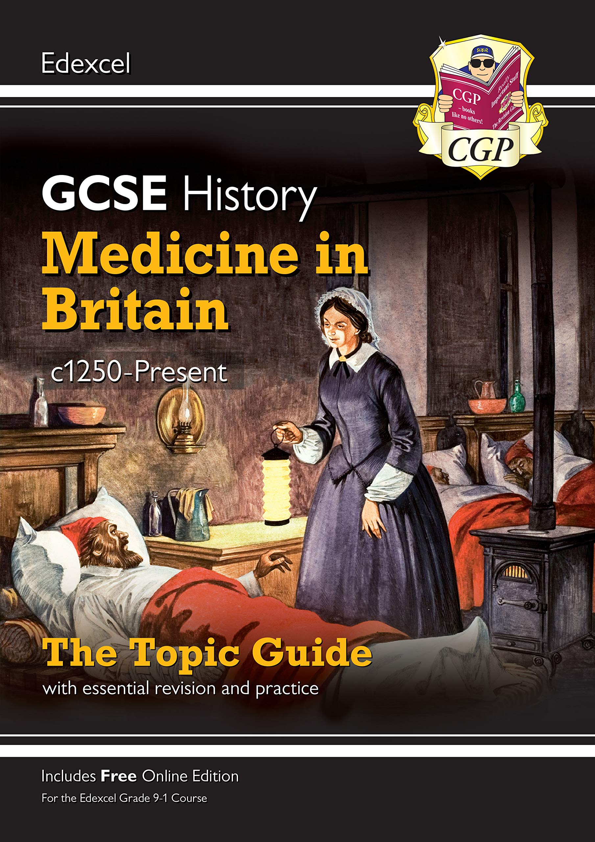
Unit 1: CGP Medicine in Britain c1250-Present
ISBN: 978-1789082890
Unit 4: CGP Weimar and Nazi Germany
ISBN: 978-1789082876
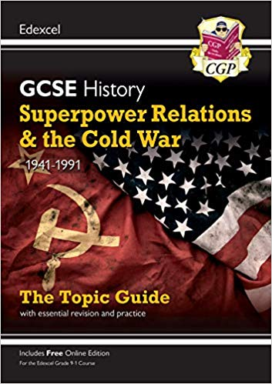
Unit 3: CGP Superpower Relations 1941-1991
ISBN: 978-1789082883
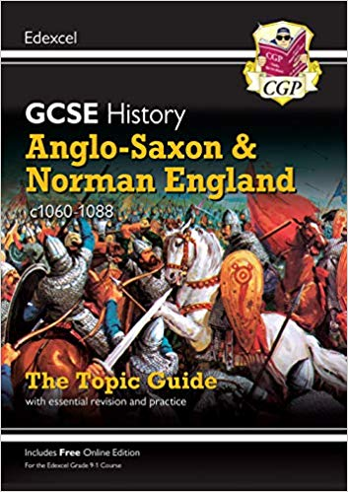
Unit 2: CGP Anglo-Saxon and Norman England
ISBN: 978-1789082937

The department are recommending the following revision books for the Edexcel 9-1 course to support achieving grades 9-6:

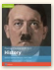
Unit 4: Pearson Foundation Weimar and Nazi Germany
ISBN: 9781292258331
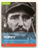
Unit 3: Pearson Foundation Superpower Relations 1941-1991
ISBN: 9781292258317
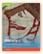
Unit 2: Pearson Foundation Anglo-Saxon and Norman England
ISBN: 9781292350127
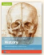
Unit 1: Pearson Foundation Medicine in Britain c1250-Present
ISBN: 9781292258348

Please do not hesitate to contact the Curriculum Area Leader of this subject
should you wish to discuss the course.

