COURSE OVERVIEW
Students follow the AQA GCSE Drama specification.

Drama provides a curriculum to ignite and engage students’ creativity, passion and interests. It also provides freedom for them to experiment and take risks with their work.
It allows students to study drama in an academic setting, interrogating this art form and applying their knowledge and understanding to the process of creating and developing drama and to their own performance work.
There’s a high percentage of practical assessment in the non-examined assessment and a single portfolio assessment for students.
Drama will encourage learners to:
- apply knowledge and understanding of drama when making, performing and responding to drama
- explore performance texts, understanding their social, cultural and historical context including the theatrical conventions of the period in which they were created (a performance text is one that has been written specifically for theatrical performance)
- develop a range of theatrical skills and apply them to create performances
- work collaboratively to generate, develop and communicate ideas
- develop as creative, effective, independent and reflective students able to make informed choices in process and performance
- contribute as an individual to a theatrical performance
- reflect on and evaluate their own work and that of others
- develop an awareness and understanding of the roles and processes undertaken in
- contemporary professional theatre practice
- adopt safe working practices.

Year 10 and 11
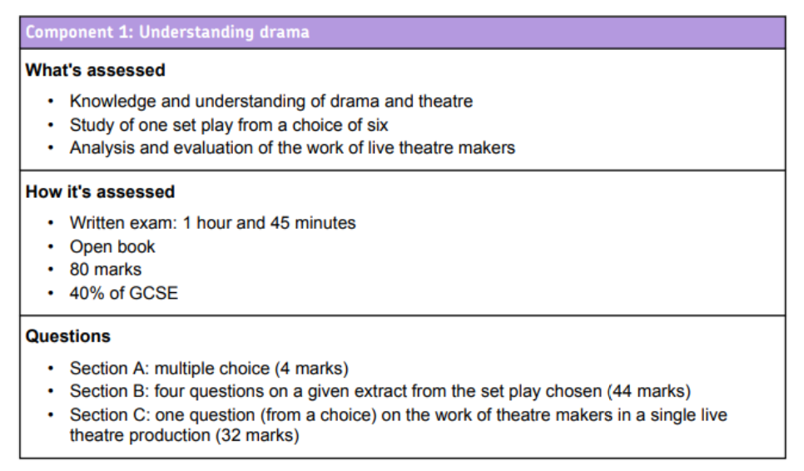
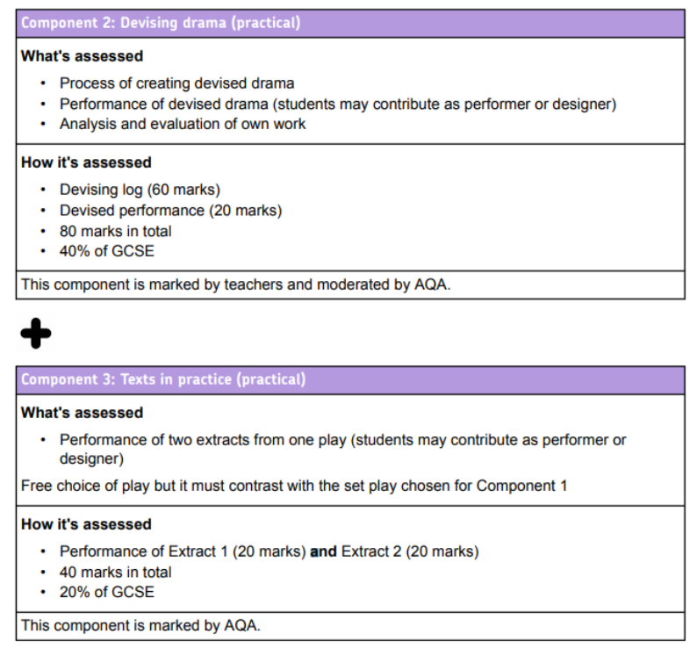
REVISION
Rooms are available each week for revision and catch up. After school 3.05-4.05. Days are flexible to fit in with revision sessions in other lessons.

OTHER CURRIULUM ACTIVITIES
- Regular theatre visits.
- External theatre companies and practitioners visit to show performances and run workshops.
- Drama club meets each week and can help students develop their performance skills.

HOW TO HELP YOUR CHILD IN DRAMA
- Support by checking homework and coursework deadlines.
- Visits to the theatre.
- Listen to them practice lines and character development.

USEFUL RESOURCES
- BBC Bitesize
- The National Theatre Website
- Any theatre website to view performances.
- You Tube is an excellent source of performance material – students work is often shown.
- Text book : AQA Drama GCSE – Annie Fox

Please do not hesitate to contact the Curriculum Area Leader of this subject
should you wish to discuss the course.

