COURSE OVERVIEW
Pupils will study the AQA Sociology GCSE specification 8192.
Sociology is about the way society works and what makes people tick. In the course your child will examine the way people organise themselves to live or work together in groups for a variety of purposes, how they react to each other, keep order within their group or society, pass on their knowledge to future generations, provide protection for individuals or the group, settle disputes between individuals or groups by peaceful or violent methods etc. It is about the problems individuals and societies face and how such problems might be tackled.

In Sociology your child will be asked to draw on their own experiences and opinions and to understand how these affect life choices. Most of the material covered in the course will have direct relevance to everyday issues and the situations facing them after they leave school.

Your child will learn a number of skills whilst studying this course. Problem solving, critical thinking and communication are top of these.

They will also learn how to investigate a topic by collecting information from books and by conducting surveys and observations; how to present the results of their investigations in both a written and a spoken form; and how to interpret and analyse different types of evidence.

The scheme of assessment consists of two written papers, each worth 50% of the overall GCSE mark

Year 10
- Introduction to course, sociology basics (concepts and theory)
- Methodology
- The Family
- Education

Year 11
- Crime and Deviance
- Stratification

EXAMINATIONS
AQA Sociology GCSE 8192
Paper 1 – The Sociology of families and education. A written paper of 1 hour and 45 minutes
Paper 2 – The Sociology of crime and deviance and stratification. A written paper of 1 hour and 45 minutes
Both papers include theory and methods throughout

CONTROLLED ASSESSMENT
End of module tests are given at the end of each module. Although this does not count towards your child’s GCSE grade, it does give a clear indication of areas that need to be focussed on.

REVISION
Revision booklets, past exam papers and model student’s answers are used in class and can be found on FIREFLY, where they can be downloaded and used at home.
Regular revision sessions will be available after school in the run up to the exams. Targeted support sessions are held throughout the year based on end of module exam results.

HOW TO HELP YOUR CHILD IN SOCIOLOGY
- Encourage your child to read the newspaper and watch the news. An awareness of current affairs will help them form an opinion on wider issues.
- Encourage your child to complete their homework and ask for help if it is needed or they are unsure of any class work.
- Encourage your child to be proactive, they are in control of their learning – if they need help ask, encourage them to use you to quiz them on definitions of terms and so on.
- Ensure that your child uses FIREFLY to access all lesson content (especially if they are absent from a lesson) and revision content.

USEFUL RESOURCES
Your child will be issued with a revision booklet for each module that they will be examined in. These will also be available on FIREFLY.
A revision book is available to buy and the cheapest place is usually Amazon. See below for the details. This covers content and exam practice.

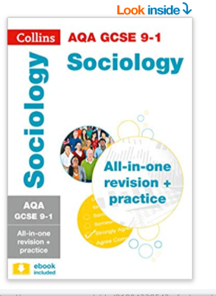

Please do not hesitate to contact the Curriculum Area Leaders (Mrs Clifton-Attfield and Mrs law) of this subject should you wish to discuss the course.

