COURSE OVERVIEW

At Jack Hunt School we have developed a Scheme of Learning that promotes deep and lasting understanding by building confidence as well as skills.
Termly Overview
There is a termly plan for each year group from Year 7 to Year 11. Each term is split into two half terms of six weeks, each with a common theme. Every half term is further split into blocks that ensure students spend enough time to get a deep understanding of the topic being covered.
Interleaving
The scheme of work has been designed with interleaving (revising topics within the context). In addition, we have starter tasks and homework that will strengthen students understanding on key topics throughout the year. Students are regularly assessed with mini end of topic tests and larger termly tests that cover more content.
Calculator Skills
2 out of the 3 papers at GCSE are calculator papers. To ensure students are confident in using their calculator they do weekly calculator skills checks. Calculator skills are also embedded throughout the scheme of learning to ensure students are confident and efficient using their calculator. It is therefore vitally important that students have the correct scientific calculator both in lessons and to use at home.

GCSE
GCSE FOUNDATION
We use the Edexcel exam board
(Grade 5 -1)
GCSE HIGHER
We use the AQA exam board
(Grade 9-3)

Tier | Foundation | Higher
Exam Board | Edexcel | AQA
Grades | 5-1 | 9-3
Examination Date | May/June 2022
Papers | 3 written papers  Paper 1 (Non-Calc), Paper 2 (Calc) & Paper 3 (Calc)
Marks | Each paper contains 80 marks
Time | 1 & ½ hours for each paper
Topics Covered | Statistics & Probability, Number & Algebra, Geometry & Measures, Ratio, Proportion and Rates of Change
Success Criteria | All pupils are aware of their target grades for Mathematics. Grade boundaries for each examination series vary and are published along with the results each summer.
Coursework | There is no coursework element for these specifications.

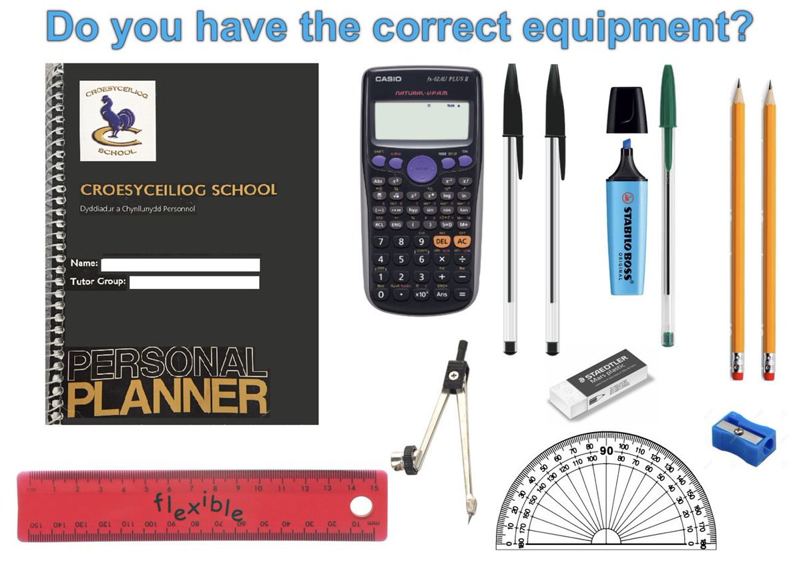
HOW TO HELP YOUR CHILD IN MATHEMATICS
Encourage students to be appropriately prepared for their mathematics lessons, with a calculator (fx-83GT X) and geometric equipment as well as the basics of pen, pencil and ruler.
Support student with homework by ensuring it is completed or email their maths teacher for support.

WHAT THE STUDENTS SHOULD BE DOING

Regular classroom assessments will allow students to measure their progress towards target grades. Every student will have a progress tracker in their books that can indicate areas of focus. Below are the websites we recommend for students to use to target their key areas:

Past papers – https://www.mathsgenie.co.uk/gcse.html

Corbett maths – https://corbettmaths.com/

GCSEPod - https://members.gcsepod.com/login/

Sparx – www.sparxmaths.com

We recommend using the CGP- Workbooks/Study Guides which are available to purchase from our school shop. Make sure you order the Edexcel book if you are studying the Foundation course and the AQA book if you are studying the Higher course.

Do not leave revision until the week or two before the exam!

Please do not hesitate to contact Miss Flowers should you wish to discuss the course.

