COURSE OVERVIEW
Students will study a full Edexcel GCSE in Religion, Philosophy & Ethics (RPE).

Students will study four different topics at Year 10 focussing on Christianity and a further four topics in Year 11 focussing on Islam. Below is a brief overview of each unit. Please refer to the ‘Year 9 Choices: Dreams and Aspirations’ booklet for a full course outline. This can be found on the School Website.

In Year 10 – The Religion, Peace and Conflict (Islam) exam provides students with an in depth study of Islam, its beliefs and teachings on life specifically about the issues of peace and conflict, and crime and punishment. This approach encourages students to reflect upon the links between beliefs and teachings of Islam and the issues of peace and conflict and crime and punishment which are part of life today. This exam will be separated into the following four topics:

- Muslim Beliefs
- Crime and Punishment
- Living the Muslim life
- Peace and Conflict

In Year 11 – The Religion and Ethics (Christianity) exam provides students with an in depth study of Christianity, its beliefs and teachings on life specifically within families and with regard to creation. This approach encourages students to reflect upon the links between beliefs and teachings of Christianity and the topics of families and creation which are an important part of life today. This exam will be separated into the following four topics:

- Christian Beliefs
- Marriage and the Family
- Living the Christian Life
- Matters of Life and Death

EXAMINATIONS
GCSE RPE is 100% examination. Students will sit two exams at the end of summer term in Year 11, each exam will last 1 hour and 45 minutes. There are no higher or foundation tiers within Religious Education, all students sit the same examinations.

REVISION
Revision materials and source booklets will be made available to all students. PowerPoints and exam technique information will be available from Firefly. There will be twilight sessions running all year round enabling pupils to catch-up/revise for this course. There is also the opportunity to attend Saturday Schools.

HOW TO HELP YOUR CHILD IN RELIGION, PHILOSOPHY & ETHICS
- Encourage your child to read newspapers and look at websites to cut clippings about ethical issues to help with their knowledge about topics studied at GCSE.
- Encourage your child to watch the news to follow ethical and religious issues to help with their knowledge.
- Support the use of using sources by linking to what scholars, religious books, the media and key people have said/quoted. This is a key part of the exam now.
- Ask your son or daughter to explain religious attitudes to ethical and religious issues studied including examples to encourage deeper knowledge and understanding.

USEFUL RESOURCES
There are two textbooks that will be used over the two year course. Both of these books have been designed specifically for the Edexcel course.
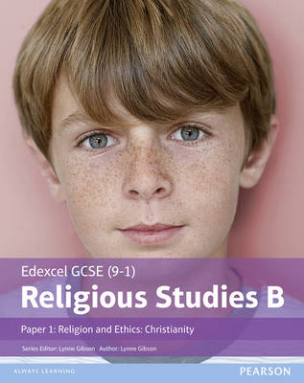

EDEXCEL Religious Studies B
Religion and Ethics: Christianity

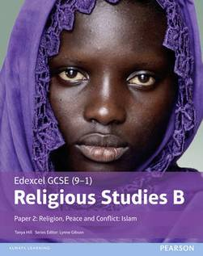

EDEXCEL Religious Studies B
Religion, Peace and Conflict: Islam

www.edexcel.co.uk http://www.bbc.co.uk/education/subjects/zb48q6f

Please do not hesitate to contact Mrs Rehman the Curriculum Area Leader of this subject should you wish to discuss the course further.

