COURSE OVERVIEW

Pupils are studying AQA GCSE Design and Technology 8552.
GCSE Design and Technology will prepare students to participate confidently and successfully in an increasingly technological world. Students will gain awareness and learn from wider influences on Design and Technology including historical, social, cultural, environmental and economic factors. Students will get the opportunity to work creatively when designing and making and apply technical and practical expertise.

The course allows students to study core technical and designing and making principles, including a broad range of design processes, materials techniques and equipment. They will also have the opportunity to study specialist technical principles of timber based materials in greater depth.

Assessment is done in two parts, exam and non-exam assessment (coursework). Both assessments are worth 50% and will take pace in year 11.

Below is a brief overview of the two year course. Please refer to the ‘Year 9 Choices: Dreams and Aspirations’ booklet for a full course outline. This can be found on the School Website.

Year 10- Pupils learn core and specialist technical principles through a range of activities
Year 11- Pupils work on their NEA, applying designing and making principles. They will also prepare for their exam.

Pupils study Core technical principles common to all areas of Design Technology that consist of;

- New and emerging technologies.
- Energy generation and storage.
- Developments in new materials.
- Systems approach to designing.
- Mechanical devices.
- Materials and their working properties.

Pupils will also study Specialist technical principles through timber based materials;

- Selection of materials or components
- Forces and stresses
- Ecological and social footprint
- Sources and origins
- Using and working with materials
- Stock forms, types and sizes
- Scales of production
- Specialist techniques and processes
- Surface treatments and finishes

Pupils will study the following Designing and making principles, chiefly when they are completing the NEA in year 11.

- investigation, primary and secondary data
- environmental, social and economic challenge
- the work of others
- design strategies
- communication of design ideas
- prototype development
- selection of materials and components
- tolerances
- material management
- specialist tools and equipment
- specialist techniques and processes

ASSESSMENT

Non-exam assessment – 50%
The NEA project in its entirety should take between 30-35 hours to complete and consist of a working prototype and a concise portfolio of approximately 20 pages of A3 paper. Students' work should consist of an investigation into a contextual challenge, defining the needs and wants of the user and include relevant research to produce a design brief and specification. Students should generate design ideas with flair and creativity and develop these to create a final design solution (including modelling). A manufacturing specification should be produced to conclude design findings leading into the realisation of a final prototype that is fit for purpose and a final evaluation. Students should investigate, analyse and evaluate throughout the portfolio and evidence all decisions made. Six criteria are produced for assessment and there are a number of points within each.

Exam- 50%
Pupils will take a number of exams throughout Years 10 and 11 to give them good practice with the format and style of questioning in preparation for their final exam in the summer term. It is a singled tiered examination. There is a mix of question styles and it focuses on applying the knowledge gained over the full two year course.

SUCCESS CRITERIA
All pupils are aware of their target grades for Design Technology

Revision
Pupils will receive a detailed revision list prior to all exams taken; mock and the final exam. There will also be sessions to support exam preparation leading up to the final exam in the summer term.

Other Curriculum Activities
We offer an after school club for all Design Technology pupils every week, where pupils can catch up with work, or continue to progress their NEA within the workshop or ICT room. Pupils can also revise and gain support from staff regarding exam preparations.

How To Help Your Child In Design Technology
- Encourage him/her to attend the sessions after school.
- Ask him/her to explain what new terminology and theory based items they have explored to enhance more in depth understanding.
- Inspire him/her to research products in general to decide what style, design or technology they like and dislike, what is well designed and made, how and why.
- Motivate him/her to look at artists and designers work on the internet, in books, newspapers, magazines, exhibitions and museums to decide which they like and why.

USEFUL RESOURCES
We use a range of text books during the Units; however, there are two which have been specifically designed for this course:

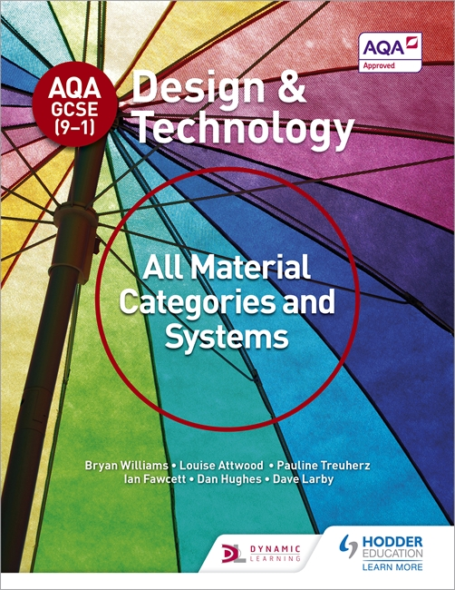 | AQA GCSE (9-1) Design and Technology: All Material Categories and Systems  ISBN: 1510401083 | 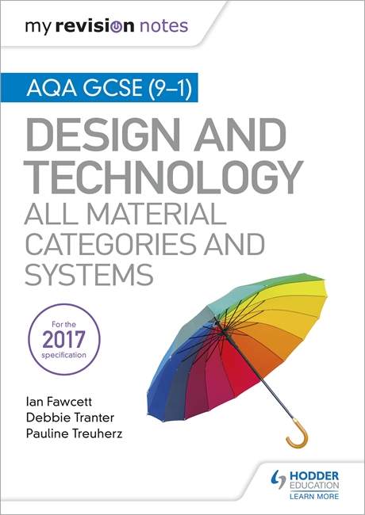 | My Revision Notes: AQA GCSE (9-1) Design and Technology: All Material Categories and Systems  ISBN: 1510432310

Websites which can help are:
www.technologystudent.com/ (website for students studying all areas of Design and Technology. The new Design and Technology section is excellent)

https://www.data.org.uk/campaign/education-the-economy-and-dt (reasons for studying Design Technology explained by key speakers and industry leaders)

http://www.aqa.org.uk/subjects/design-and-technology/gcse/design-and-technology-8552 (exam specification and resources supporting the course.)

Please do not hesitate to contact the Curriculum Area Leader of this subject
should you wish to discuss the course.

