COURSE OVERVIEW
The Ancient History course is comprised of the following units:
OCR 9-1 Ancient Historians study 4 units
- The Persian Empire, 559–465 BC
- Athens in the Age of Pericles, 462-429 BC
- The foundations of Rome: from kingship to republic, 753–440 BC
- Hannibal and the Second Punic War, 218–201 BC

EXAMINATIONS
OCR 9-1 Ancient History has 2 exams of 105 minutes.
- Exam 1 – The Persian Empire and Athens in the Age of Pericles – 50%
- Exam 2 – The foundations of Rome and Hannibal – 50%

All exams will be sat in Summer 2023

REVISION
We aim to finish teaching by February Half Term 2023. This will allow teachers to start revision after the break. We offer revision sessions and evening schools to support revision.
We will also provide students with bespoke revision packs which support students to reach their potential. These resources will be stored on students iPad either using the OneDrive app or the OneNote app.
Finally, we also have a vast number of resources on Firefly which have been produced by the department. These include practice papers, revision guides and exemplar answers. These can be found using the link below:
https://jhs.fireflycloud.net/history/ks4/gcse-9-1-ancient-history
HOW TO HELP YOUR CHILD IN HISTORY
The biggest help we can receive from parents is testing students on their knowledge.
We have produced a series of knowledge quiz booklets. Please try to test students 3-4 times a week on a variety of topics. They contain the key learning that everyone must know if they wish to achieve a good grade. The knowledge test booklets can be found on Firefly, please use the link below:
https://jhs.fireflycloud.net/history/ks4/gcse-9-1-ancient-history/revision-resources/knowledge-tests---persia
These will also be emailed out via ParentMail. Please look out for emails from the History department.
Also encourage your child to access the revision resources on Firefly. These include practice question booklets which will help students with exam technique and resources such as revision cards which you could help to test student’s knowledge at home.
Finally encouraging students to access the following resources will also help to improve their grades.
- Massolit - This resource contains a series of lectures on Ancient History. This will help students to recap their knowledge and extend their knowledge for the top grades. Students can sign up to the website using their @jhs.pkat.co.uk email address.
https://massolit.io/
- Historical Association – This resource contains a series of podcasts, articles and more to help students recap and extend their knowledge. Students should ask their teacher for the login details.
https://www.history.org.uk/

USEFUL REVISION GUIDES
Currently there are no revision guides for the OCR 9-1 Ancient History course. However, there are course textbooks available which the student use in class and can support their learning outside of the classroom. These can be loaned out via the library.

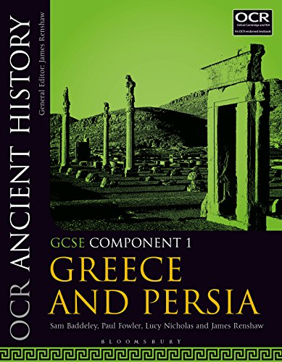
OCR Ancient History Component 1: Greece and Persia
ISBN: 9781350015159
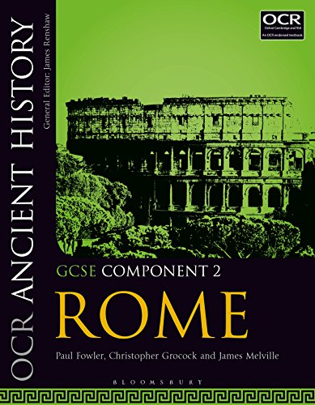
OCR Ancient History Component 2: Rome
ISBN: 9781350015197

Please do not hesitate to contact the Curriculum Area Leader of this subject
should you wish to discuss the course.

