COURSE OVERVIEW
Our Geographers study the Edexcel GCSE (9-1) Geography A syllabus.
All students sit the same examination paper, which includes multiple-choice questions, short open, open response, calculations and 8-mark extended writing questions. Up to 4 marks are awarded for spelling, punctuation, grammar and use of specialist terminology (SPAGST) on each paper. There are three examinations which will be sat in summer 2024.

Paper | Topics | Assessment | Percentage of GCSE
1 The Physical Environment | • Changing Landscapes of the UK  • Coastal Landscapes & Processes  • River Landscapes & Processes  • Weather Hazards & Climate Change  • Ecosystems, Biodiversity & Management | Exam Time:  1 hr 30 mins  Total Marks Available: 94 | 37.5%
2 The Human Environment | • Changing Cities  • Global Development  • Resource Management & Water Security | Exam Time:  1 hr 30 mins  Total Marks Available: 94 | 37.5%
3 Geographical Investigations: Fieldwork and UK Challenges | - Geographical Investigations – Coast  - Geographical Investigations – Inner, Urban Area  - UK Challenges | Exam Time:  1 hr 30 mins  Total Marks Available: 64 | 25%

REVISION
We aim to finish teaching the course by Easter 2024. This will allow teachers to start revision after the Easter break. We offer revision sessions and evening schools to support revision. We will also provide students with bespoke revision packs which support students to reach their potential, these resources will be stored on students iPad either using the OneNote app.
Each student will be able to use their login details for a number of GCSE Geography apps (Geography PiXL App, GCSE Pod, Educake) to use on their iPad to support their learning at home. Finally, we also have a vast number of resources on Firefly which have been produced by the department. These include practice papers, revision guides and knowledge tests, all of which can be found using the link below:
https://jhs.fireflycloud.net/geography/ks4

FIELDTRIPS
A requirement of the course is to undertake two days of fieldwork out of a school setting. The experience of fieldwork helps students to develop new geographical insights into two contrasting environments and to apply their geographical knowledge, understanding and skills in a fieldwork setting.

HOW TO HELP YOUR CHILD IN GEOGRAPHY
The biggest help we can receive from parents is testing students on their knowledge. As a department we have produced a series of knowledge quiz tests to support this found using the OneNote app. Please try to test students 3-4 times a week on a variety of topics. They contain the key learning that everyone must know if they wish to achieve a good grade.

Finally encouraging students to access the following resources will also help to improve their grades.
- GCSE Pod - Students can use GCSE Pod to watch videos 3-5 minutes in length. The department has created question booklets that students answer. It would then benefit students to be tested on this knowledge – so please ask to see their booklets. This can be accessed via their iPads and students should email their teachers if they have forgotten their login details. https://www.gcsepod.com/
- Pixl Geography App - Students have a login for the Pixl Geography app which can be accessed via their iPads. This can be accessed on a computer or via the app on a phone or tablet. This contains knowledge quizzes to test students’ knowledge on all topics. https://geographyapp.pixl.org.uk/
- Educake - Student have a login for the Educake app which can be accessed via their iPads. Students can create their own self-marking quizzes which can be used for testing knowledge and finding areas they need to improve on. https://www.educake.co.uk/
Also encourage your child to access the revision resources on Firefly. These include practice question booklets which will help students with exam technique and resources such as revision cards which you could help to test student’s knowledge at home.

Geographers need to be able to transfer their mathematical skills across to into lessons and revision. Many of their numerical, graphical and statistical skills will be tested in each paper. A calculator must be used in all three exams, please ensure they arrive at their Geography lessons with the correct equipment to aid their learning.

USEFUL RESOURCES
We use a range of textbooks during the two year course which students will have electronic access to via their iPads. The department are recommending the following revision books to aid learning.

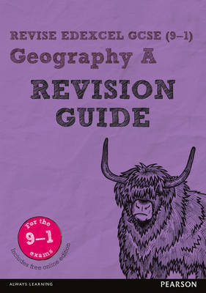  Revise Edexcel GCSE (9-1) Geography A Revision Guide  ISBN: 9781292133775 | 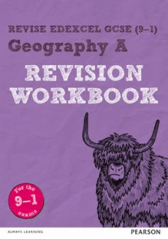  Revise Edexcel GCSE (9-1) Geography A Revision Workbook: for the 9-1 exams  ISBN: 978-1292133775
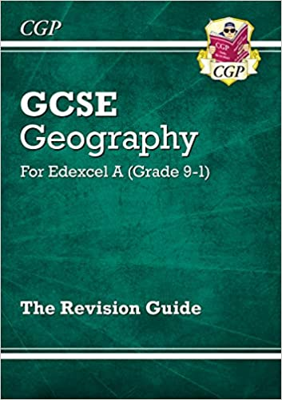  Grade 9-1 GCSE Geography Edexcel A – Revision Guide  ISBN: 978-1789083019 | 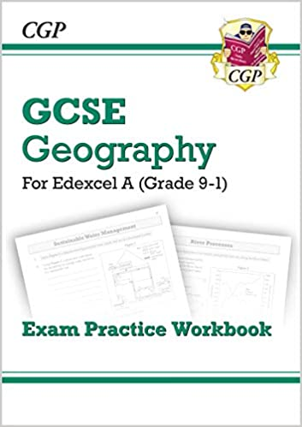  Grade 9-1 GCSE Geography Edexcel A - Exam Practice Workbook  ISBN: 978-1789083026

Please do not hesitate to contact the Curriculum Area Leader of this subject
should you wish to discuss the course.

